**DAILY ONLINE ACTIVITIES SUMMARY**

|  |  |  |  |  |  |
| --- | --- | --- | --- | --- | --- |
| **Date:** | **16-06-2020** | | | **Name:** | **SAHANA C** |
| **Sem & Sec** | **6th - B** | | | **USN:** | **4AL17CS116** |
| **PRE-PLACEMENT TRAINING** | | | | | |
| **Subject** | **C-Programing and Python workshop** | | | | |
| **Max. Marks** | **--** | **Score** | | | **--** |
| **C-Structures**  **Python workshop** | 9:00 to 10:30 Mrs. Merlin melita  10:00 to 1:00 Dr. Mohideen Badhusha | | | | |
| **Coding Challenges** | | | | | |
| **Problem Statemen:**  **1.python program to check given tree is BST or NOT** | | | | | |
| **Status: executed** | | | | | |
| **Uploaded the report in Github** | | | **yes** | | |
| **If yes Repository name** | | | **https://github.com/sahanasanu/Daliy-status** | | |
| **Uploaded the report in slack** | | | **Yes** | | |

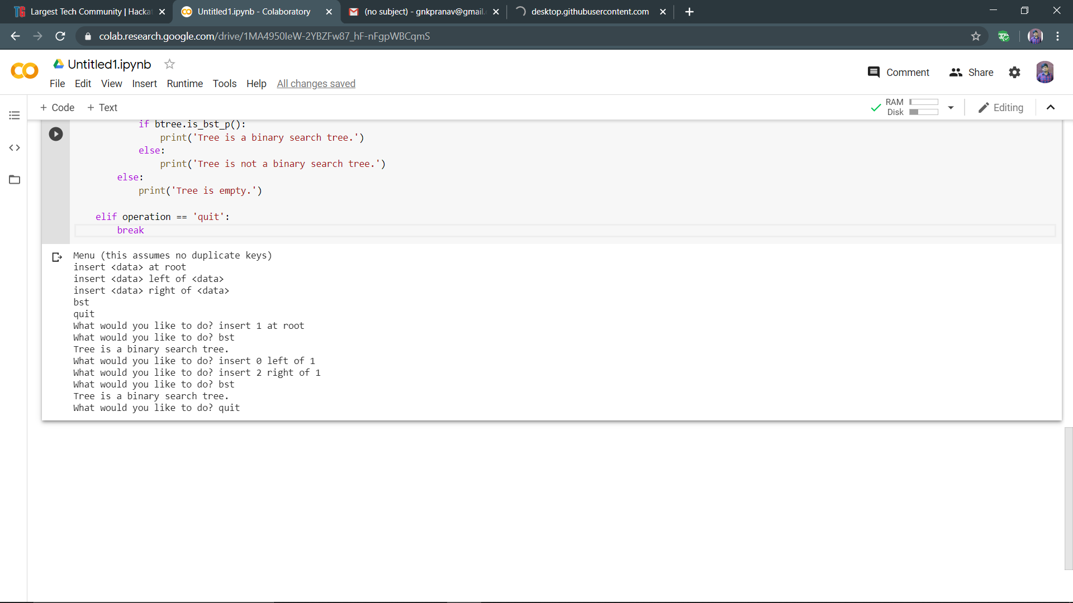ONLINE TEST DETAILS ONLINE PROGRAMS:

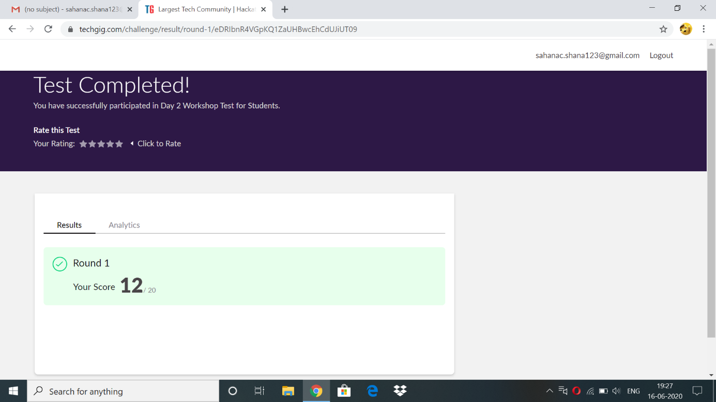

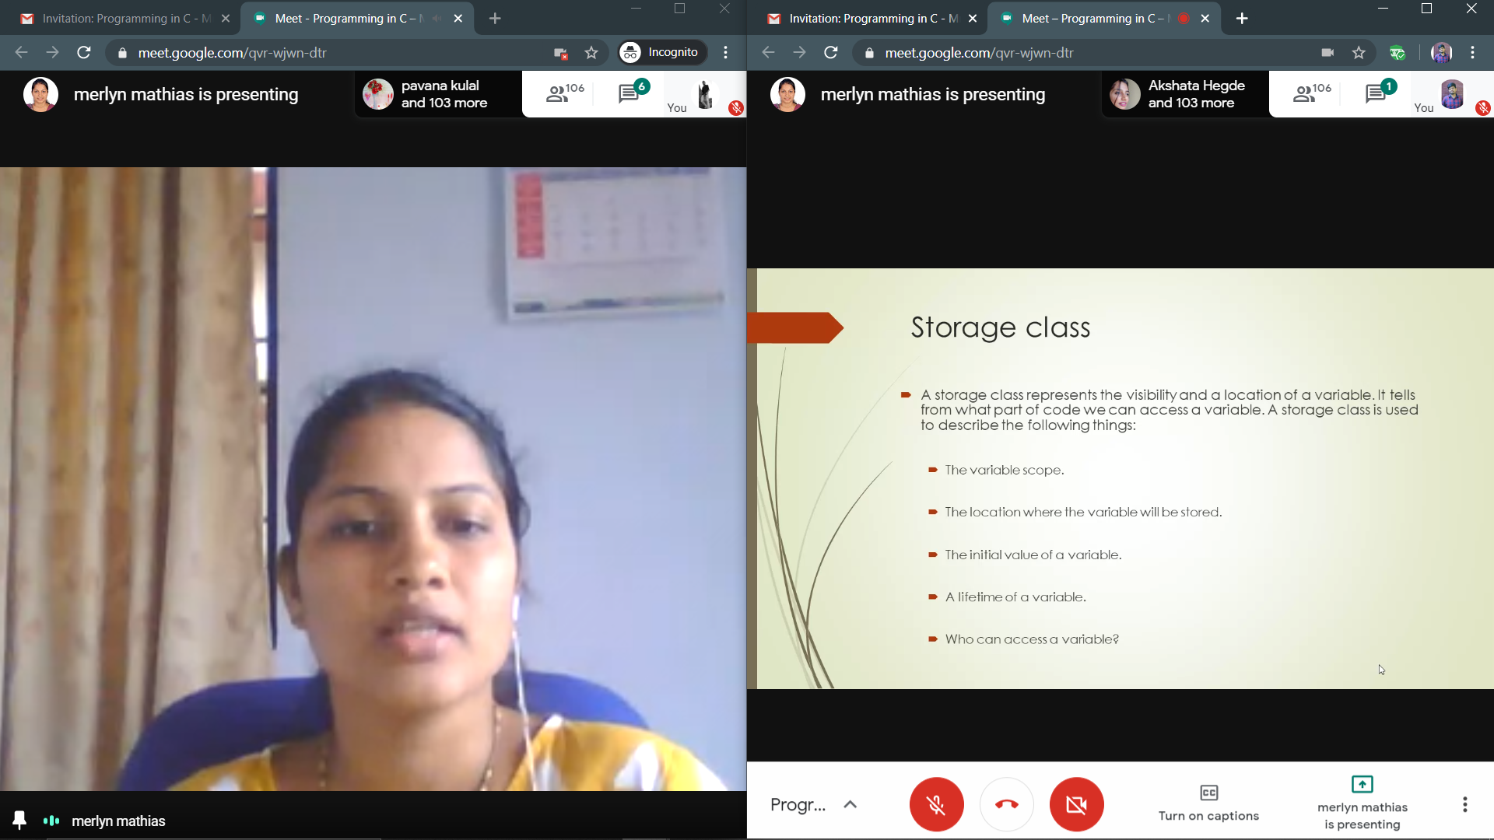ONLINE TRAINING:

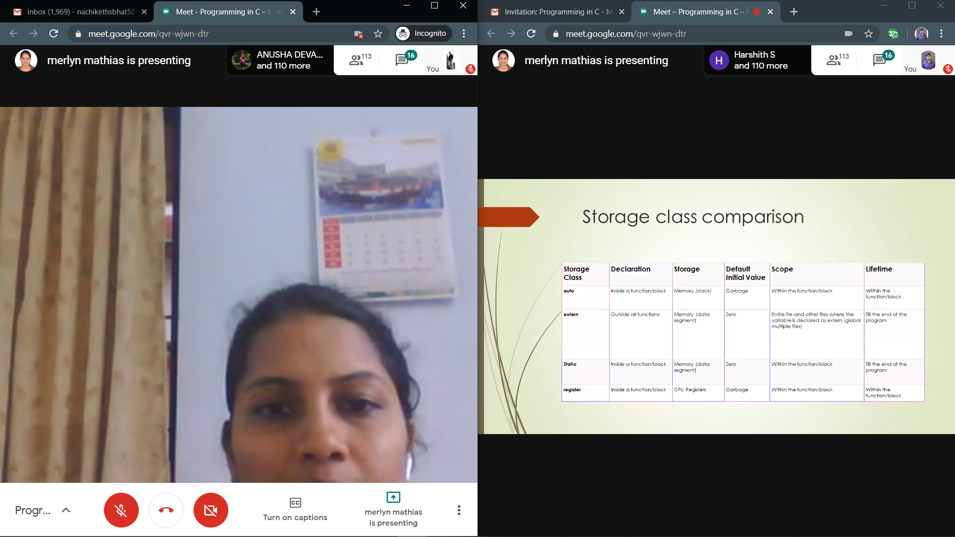

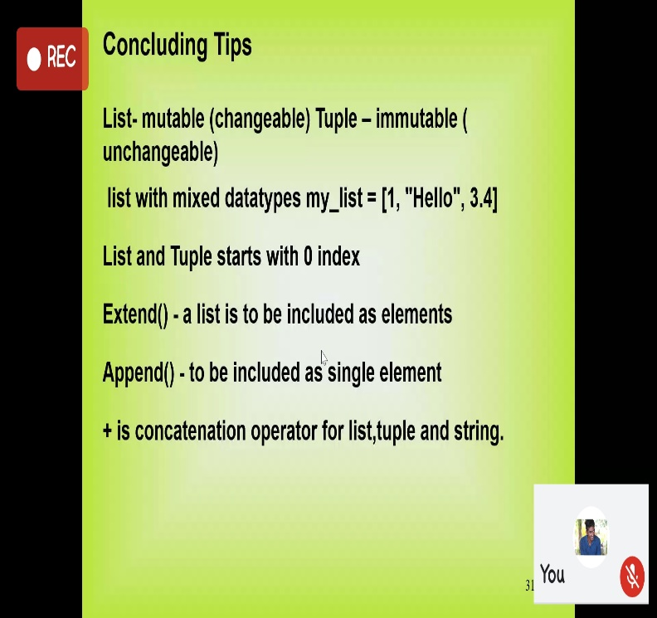

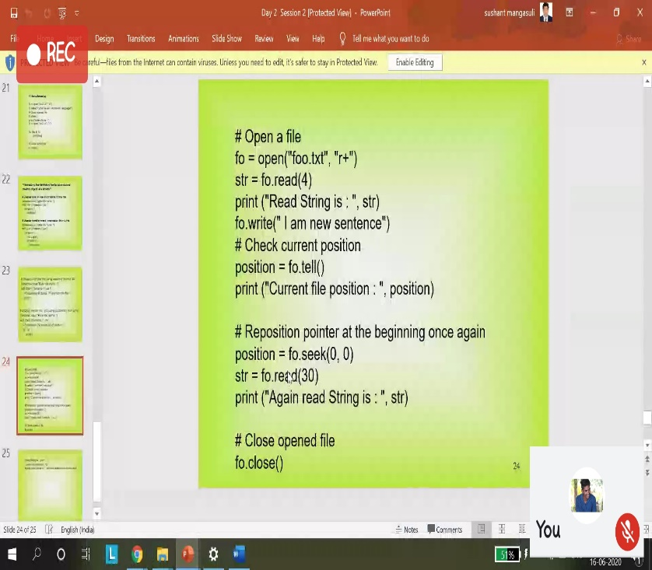

Python workshop :

**Assessments:**

**Uploaded in github account and respective links are provided.**

**https://github.com/sahanasanu/pre-placement-training**

CODDING CHALLENGE:

Write a Python program to check whether a given a binary tree is a valid binary search tree (BST) or not?

class TreeNode(object):

    def __init__(self, x):

        self.val = x

        self.left = None

        self.right = None

def is_BST(root):

    stack = []

    prev = None

    while root or stack:

        while root:

            stack.append(root)

            root = root.left

        root = stack.pop()

        if prev and root.val <= prev.val:

            return False

        prev = root

        root = root.right

    return True

root = TreeNode(2)

root.left = TreeNode(1)

root.right = TreeNode(3)

result = is_BST(root)

print(result)

root = TreeNode(1)

root.left = TreeNode(2)

root.right = TreeNode(3)

result = is_BST(root)

print(result)

Write a Python program to check whether a given a binary tree is a valid binary search tree (BST) or not?

class TreeNode(object):

    def __init__(self, x):

        self.val = x

        self.left = None

        self.right = None

def is_BST(root):

    stack = []

    prev = None

    while root or stack:

        while root:

            stack.append(root)

            root = root.left

        root = stack.pop()

        if prev and root.val <= prev.val:

            return False

        prev = root

        root = root.right

    return True

root = TreeNode(2)

root.left = TreeNode(1)

root.right = TreeNode(3)

result = is_BST(root)

print(result)

root = TreeNode(1)

root.left = TreeNode(2)

root.right = TreeNode(3)

result = is_BST(root)

print(result)

